Problem: Funding gap is not due to lack of generosity, but rather a lack of incentives → psychological barriers (temporal discounting, abstractness, and scope insensitivity)

Current solution: Economic services valuation (ESV) to translate ecological benefits into monetary benefits

Issue: can be perceived as “greedy” or “cheapening” of a “priceless” resource

Wetland model: studies have explicitly calculated the value of wetlands in reducing storm surge

Corals provide tangible indirect-use services like coastal protection, acting as a natural breakwater, and protecting coastal homes and vital infrastructure

Job creation
There are now about one billion people (13% of global population) living in coastal regions near coral reefs. These populations are growing faster than the global average. Many people living in these coastal reef communities are dependent on reefs for their livelihoods – be it fisheries, tourism, or other marine industries. InAustralia, the Great Barrier Reef is estimated to support over 60,000 jobs with an economic value of over $56 billion.

Valuing the cost of doing it versus just the profit itself
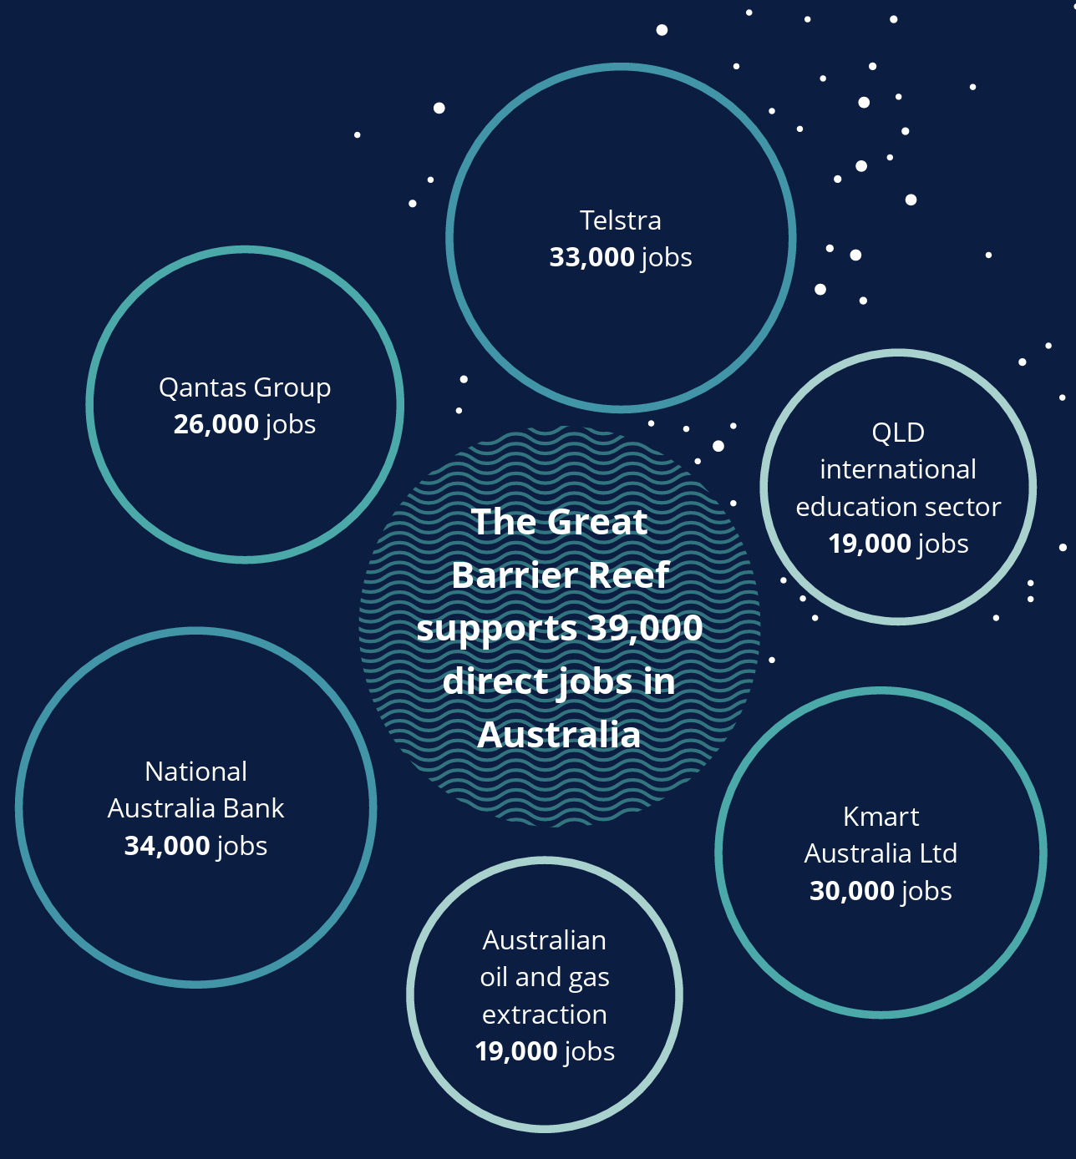

More personal - numbers are hard to grasp

Primary research questions:
- what would motivate people individually
- People of different statuses and backgrounds
- What motivates different groups to contribute

What kind of motivation would get different stakeholders to take action?
What do people currently care about → why do they care → how to translate it?
Insurance
Wetland model
Storytelling

Can we connect coral reefs to a larger problem → fish → world hunger → global warming etc

Connect with groups around LA about coral restoration

